MUNICIPAL COURT ADMINISTRATORS ASSOCIATION OF NEW JERSEY
2026 MEMBERSHIP APPLICATION
Per the by-laws, only Municipal Court Administrators, Court Directors, Deputy Court Administrators and any NJ Municipal Court Employee who is recognized as a Certified Municipal Court Administrator (CMCA) may be members.
MEMBERSHIP FEE is $100.00 per person
ALL DUES MUST BE PAID OR VOUCHERED BY MARCH 1, 2026 PER THE BY- LAWS.
Please type or print clearly.
NAME _ TITLE _ MUNICIPAL COURT _ _
ADDRESS -_ -____ TELEPHONE NUMBER ____
FAX NUMBER _ EMAIL ADDRESS ____
MAKE CHECKS PAYABLE TO: MCAA OF NJ ENCLOSE THE FOLLOWING:
- TWO SELF-ADDRESSED STAMPED ENVELOPES
- COMPLETED MEMBERSHIP APPLICATION FOR EACH PERSON
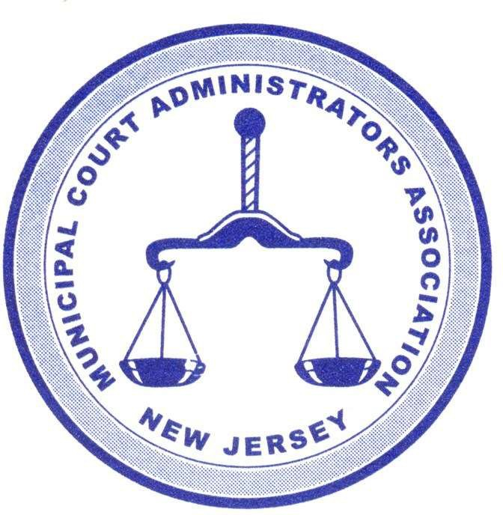
- VOUCHER AND/OR PAYMENT
SEND TO:

MCAA OF NJ
C/ O AMANDA PRINZO, CMCA
MUNICIPAL COURTS OF WALL, SEA GIRT AND SPRING LAKE HEIGHTS
2700 ALLAIRE ROAD
WALL, NJ 07719
FOR FURTHER INFORMATION PLEASE CONTACT: Amanda Prinzo, CMCA TELEPHONE: 732-449-4666
E-Mail: amanda.prinzo@njcourts.gov

