**MUNICIPAL COURT ADMINISTRATORS ASSOCIATION OF NEW JERSEY**

**2025 MEMBERSHIP APPLICATION**

Per the by-laws, only Municipal Court Administrators, Court Directors, Deputy Court Administrators and any NJ Municipal Court Employee who is recognized as a Certified Municipal Court Administrator (CMCA) may be members.

**MEMBERSHIP FEE is $100.00 per person**

**ALL DUES MUST BE PAID OR VOUCHERED BY MARCH 1, 2025 PER THE BY- LAWS.**

**Please type or print clearly.**

**NAME** **TITLE** **MUNICIPAL COURT** **ADDRESS** **TELEPHONE NUMBER** **FAX NUMBER** **EMAIL ADDRESS**

MAKE CHECKS PAYABLE TO: MCAA OF NJ ENCLOSE THE FOLLOWING:

1. **TWO SELF-ADDRESSED STAMPED ENVELOPES**
2. **COMPLETED MEMBERSHIP APPLICATION FOR EACH PERSON**
3. 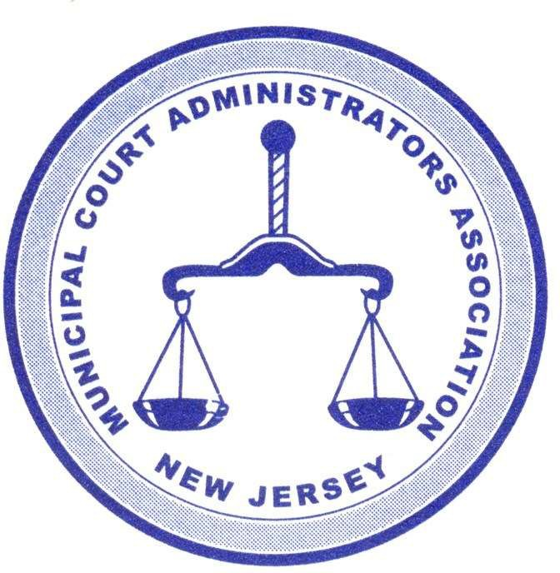**VOUCHER AND/OR PAYMENT**

**SEND TO:**

**MCAA OF NJ C/O**

**Karen Gomez, CMCA**

**West New York Municipal Court 428 60th Street RM 17**

**West New York, NJ 07093**

**FOR FURTHER INFORMATION PLEASE CONTACT: Karen Gomez, CMCA TELEPHONE: 201-295-5193**

**E-Mail:** [**karen.gomez@njcourts.gov**](mailto:karen.gomez@njcourts.gov)